CENWP-OD-B 12 July 2024

MEMORANDUM FOR THE RECORD

SUBJECT: 24BON025 MFR WA Shore AWS RB1 Pacific Lamprey Mortalities

On the morning of 12 July 2024, Project Biologists discovered two Pacific Lamprey mortalities in Rest Box 1 of the Washington Shore Auxiliary Water Supply LPS (WA Shore AWS RB1). Both fish were inspected, measured, scanned for PIT tags, and returned to the river.

- Species – Pacific Lamprey (Entosphenus tridentatus)
- Origin – Unknown
- Length – From left to right: 64.77cm, 71.12cm
- Marks and tags – None
- Marks and Injuries found on carcass – None, other than hemorrhaging from gill holes
- Cause and Time of Death –Unknown
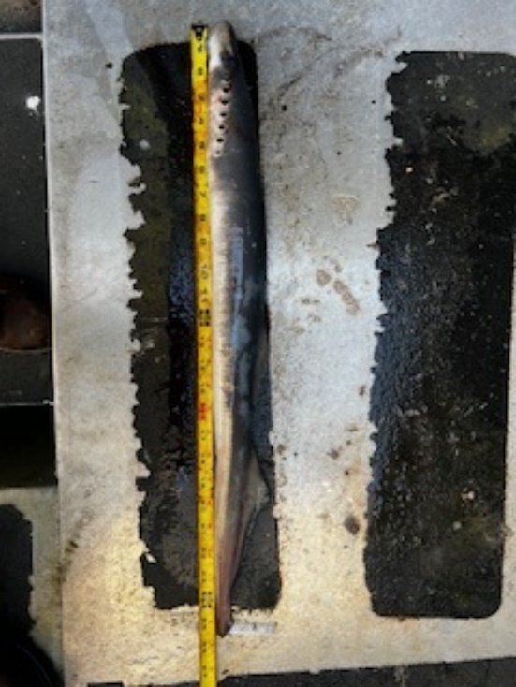
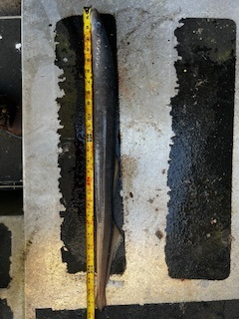
- Future and Preventative Measures – N/A

Sincerely,
Project Fisheries

